CentRes POS

# **Status Update: Sprint** 1 **– Week** 2

**Submitted by:** S. Andy Short

## **TRELLO BOARD**

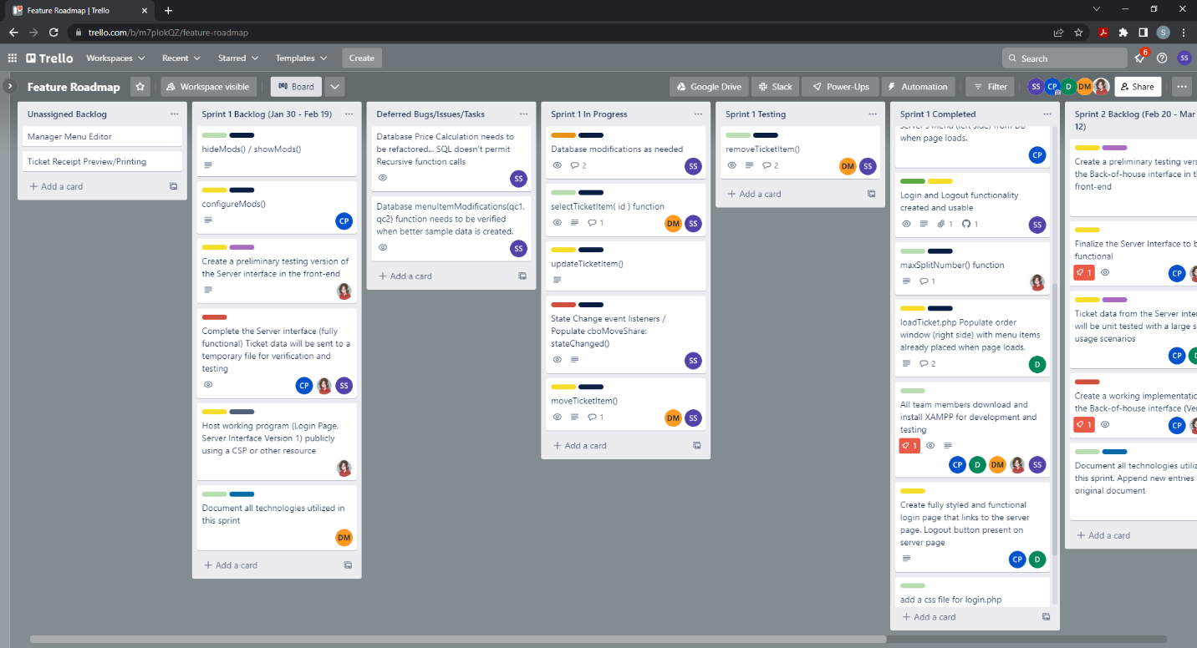

Note: The team is taking a bottom-up approach. Dependent functionality has been deferred to late in the sprint. This ensures the underpinnings of or our implementations will work correctly. Our goal is to mitigate unexpected behavior that is hard to troubleshoot and debug.

## **STATUS UPDATE DETAILS**

### **Tasks Accomplished**

1. Implemented listeners for ticket and table assignments (to check for external changes)

2. Implemented select/multi-select functionality to ticket container.

3. Introduced a consistent styling to the login and server view.

4. tested and verified listeners work correctly.

5. Converted the menu and ticket “displays” to iframe.

6. Wrote display.php and displayInterface.js to provide mechanism to pass and retain data to and from pages contained in an iframe tag.

7. Changed all the click events to pointerdown. This has been tested on 1 tablet. The server view can be operated on a desktop, or a touch enabled device.

8. Created sample menu data to test with. This data will be used for the sprint 1 demo.

9. Created a startup script for the customer. Customer has just opened a restaurant and has only hired 2 servers. Only 3 tables will be served within the first week of business. The owner has not hired a host/hostess. They will personally seat the patrons.

### **Problems/Challenges (include status – “resolved/not resolved”)**

1. The modification window and corresponding fields in the database were not well established in the SRS. Further discussion is required to correctly implement a single “vision” of menu modifications. The modification window may have to be delayed and pushed to the second spring. (This problem was already anticipated and it is acceptable if it is pushed to the 2nd sprint backlog.) This window was deliberately omitted from the 1st. **UNRESOLVED**

2. Latency/Lag concerns. The listeners on the server view poll the database every second. Load testing is required to see how the system will respond to a full compliment of employees accessing the database that frequently. If the load is too much, the interval each listener refreshes can be increased to make less polls per unit of time. **UNRESOLVED**

3. Menu UI isn’t user friendly. The menu display uses the details/summary html tags. This is a html native “accordion.” Concerns have been raised as to how long it will take a server to navigate to the appropriate menu category. The menu may be moved to a separate page, and only show 1 menu category at a time. It would include navigation buttons to the root and parent menu item categories. The database and current menu implementation has been designed to include nested menu categories.

**RESOLVED** Menu rework has been planned for Sprint 2. Sprint 2 was deliberately made sparse (easier features designated) in the event necessary refactoring must be implemented on the server view.

4. UI Orientation Concerns. This application operates out of a browser window. At this stage the team is assuming the screen will be oriented landscape. No consideration has been made to allow the view to be rendered in portrait mode. **RESOLVED/LOCKED.** The server view php file can lock the orientation to landscape. Testing will be conducted to make sure the document enforces this constraint on rotatable devices.

5. UI button size concerns. Some of the buttons and dropdowns are incredibly small. Styling needs to be applied to them. The elements should be large enough for an above average person’s pointer finger to fit within the bounds of the buttons and dropdowns. **UNRESOLVED**

